

**MySQL + Info-Gathering:**

**CMF - Azure MySQL Single Server Automation User Guide**

**For Script:**

**CMF-MySQL-CLI-Windows.ps1**

**CMF-MySQL-CLI-Linux.ps1**

**Document Summary**

|  |  |
| --- | --- |
| **Document Item** | **Current Value** |
| Document Title | CMF - Azure MySQL Single server Info-Gathering Automation User Guide |
| Program | CSU Migration Factory |
| Date Last Modified | 05-Oct-2023 |
| Date Last Reviewed | 05-August-2023 |
| Current Document Known Issue | N/A |
| Status | Initial |
| Document Description | This document provides the procedure/steps to execute the Automation script which gathers the Azure MySQL Single server/instance details. |

**Revision History**

This section represents the change history of the document. Revisions of the document must be tracked by identifying a new version number, the date it was modified, the person making the change, and the reason for the change.

|  |  |  |  |  |
| --- | --- | --- | --- | --- |
| Date | Version | Change Description | Author | Reviewer |
| 5-Oct-2023 | 1.0 | Initial Version | Lekshmy, Arun, Chethan,  Mukesh | Rackimuthu Kandaswamy |
| 02-Jan-2024 | 1.1 | Added SSL Mode | Lekshmy, Arun, Mukesh, Chethan | Sharad Khadtare,  Rackimuthu Kandaswamy |

Table of Contents

1. Executive Summary 4

1.1 Objective 4

1.2 Recommendations 5

2 Prerequisites for Azure MySQL Info gathering - Execution 5

2.1 Non-Mission-Critical system 5

2.2 Operating System Requirements 5

2.3 Input Excel File 6

2.4 Windows User credentials 7

2.5 Storage Space & Folder read write permission 7

2.6 Internet access 7

2.7 Internet access to the below URLs: 7

2.8 Without Internet access to theURLs 7

2.8.1 Installing Azure CLI 7

2.8.2 Installing ImportExcel Module 10

2.9 PowerShell Version, Modules & Execution policy 14

2.10 Connectivity 14

3 Copying Script 14

3.1 Folder Name 14

3.2 Renaming Scripts 16

4 Preparing the INPUT CSV File 16

5 Executing the Script 17

5.1 Azure MySQL Info Gathering execution 17

5.1.1 Create support folders( Logs, Output, Downloads etc) 18

5.1.2 Validate Azure CLI 19

5.1.3 Azure Portal authentication 20

5.1.4 Export Info-Gathering details and generating JSON files 20

5.1 Server_List CSV File 21

5.1.1 Azure MySQL Single Server JSON output 21

5.1 Azure MySQL Single Server Output excel file 22

5.2 Azure MySQL Single server Output excel file 22

5.3 Automation Script Transcript Log 23

# Executive Summary

## Objective

This document provides the procedure/steps to execute the Automation script (CMF-Azure-MySQL-Info-gathering_V1.1.ps1) which gathers the Azure MySQL Single server/instance details.

The following MySQL information is gathered from the given Azure Subscription:

* MySQL Server/instance
* Resource_Group
* VCore
* Auth_Type
* User_ID
* DB_Name
* tenant
* Subscription_ID

The following Azure MySQL CLI’s output will be exported to JSON files and excel file from the given Azure Subscription:

## Recommendations

Key recommendations are as follows:

1. Run the script on Non-Mission-Critical systems ONLY (i.e.**NOT** on any production server)
2. Windows 10, Windows Server 2012, Windows Server 2012 R2 and above
3. Connectivity must exist between the SYSTEM which runs the Azure MySQL Single Info Gathering Automation script and Azure Cloud
4. Powershell 5.1 version

**Note**: The values present in the Screenshots are demo values. Please change the values as Appropriate.

# Prerequisites for Azure MySQL Info gathering - Execution

## Non-Mission-Critical system

* **Don't install and run the Automation scripts on any mission-critical production server**

## Operating System Requirements

* Supported Operating System

Windows 10, Windows Server 2012, Windows Server 2012 R2 and above

## Input Excel File

**Important Notes:**

* This script is based on the csv file named ‘Azure_Subscription’ and the following columns in the Input csv file
* INPUT CSV FILE name must be **Azure_Subscription**
* **Column Name must be kept as shown below, change in names will result in errors**
* **Values in the column must be correct, incorrect values will also result in errors**

|  |  |
| --- | --- |
| **Column Name** | **Note** |
| **Tenant** | **Azure Subscription tenant ID** |
| **Subscription_ID** | **Azure Subscription ID** |

|  |  |  |
| --- | --- | --- |
| **Seq.No** | **File** | **Note** |
| 1 |  | Sample: **Azure_Subscription.csv (Input File)** |
| 2 |  | Sample: **Server_List.csv (Output File)** |

## Windows User credentials

Windows user must have privileges to install the following software& PowerShell module:

* Azure CLI
* ImportExcel

## Storage Space & Folder read write permission

* Windows user must have a privilege to create folder and write the assessment results to that folder
* Minimum disk free space required is 1GB

## Internet access

* Connectivity must exist between the SYSTEM which runs the Azure MySQL Info Gathering Automation script and Azure Cloud.

## Internet access to the below URLs:

|  |  |
| --- | --- |
| **URL** | **Note** |
| <https://aka.ms/installazurecliwindows> | Azure CLI |

## Without Internet access to theURLs

**Note:** Follow the below instructions to download all the software manually to a server where internet connectivity is enabled. Once all the software is downloaded, move all of them to the server where CMF-Azure MySQL Info Gathering automation script will be executed and install all of them one by one.

### Installing Azure CLI

1. Paste the download link in web - https://aka.ms/installazurecliwindows



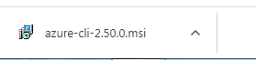

1. Launch the downloaded offline installer **azure-cli-2.50.0.msi,**

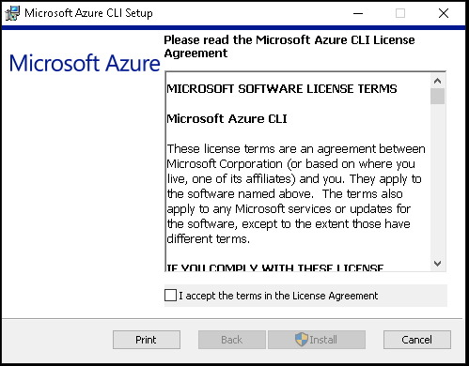

1. Read and accept the license terms.
2. Click on Install.

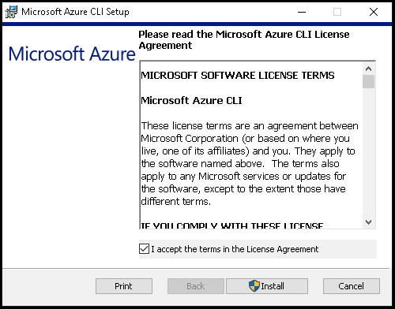

1. Azure CLI Installation is in progress

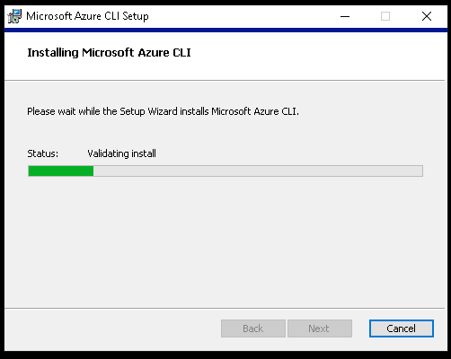

6. Once the installation is complete, click on Finish

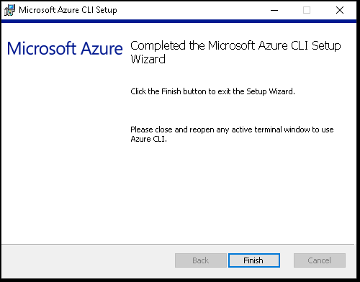

### Installing ImportExcel Module

1. Open Browser and navigate to the link <https://www.powershellgallery.com/packages/ImportExcel/7.4.1>
2. Click On Manual Download

1. Now Click on Download the raw nupkg file.
2. The file will be downloaded to Downloads folder

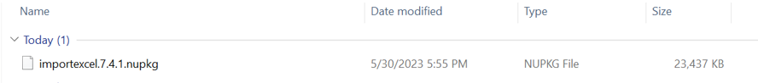

1. Right Click Properties-> and unblock the file -> Apply.

1. Rename the file as ImportExcel.zip.



1. Extract the zip RightClick-> Extract All

1. Goto Run Button -> Type Powershell and click on -> Windows PowerShell

1. Run the command. $env:PSModulePath which will list all the Environment variable paths for PowerShell Module



1. Navigate to the path which reflects with Program Files or ProgramFiles(X86) to the Respective modules Folder via FileExplorer and paste the extracted file (i.e. Step7)

Execute the below command from windows PowerShell as Administrator.

* **Import-Module ImportExcel**



## PowerShell Version, Modules & Execution policy

Execute the below commands from windows PowerShell as Administrator.

1. To find the PowerShell Version

* Get-Host

1. Set the PowerShell execution policy

* **Set-ExecutionPolicy Unrestricted -Scope CurrentUser**



## Connectivity

* Connectivity must exist between the SYSTEM which runs the Azure MySQL Info Gathering Automation script and Azure Cloud.

# Copying Script

## Folder Name

* Login into a Non-Mission-Critical system (i.e.**NOT**on any production server) from where the MySQL Automation is to be run
* Create a folder C:\MySQL (you may choose any available drive)

## Renaming Scripts

* Execute the following command in Info-Gather folder to rename the scripts from .txt to .ps1 in **Windows** Command Prompt.



* Run rename.bat file as shown below



* Execute the following command in Info-Gather folder to rename the scripts from .txt to .ps1 in **Linux** (putty)



# Preparing the INPUT CSV File

In Order to support the Info Gathering process, INPUT CSV FILE has been provided with Azure Subscription data.

**Each column will represent an Azure Subscription detail for MySQL** **Azure Single Server Info Gathering**

* Once the input file is prepared Copy the file (**Azure_Subscription.csv**) under the folder created in the previous step (C:\MySQL_Azure)

# Executing the Script

## Azure MySQL Info Gathering execution

* Open windows Command prompt as **Administrator**

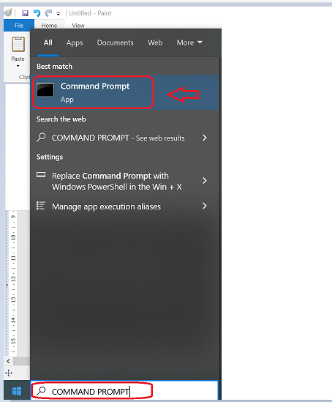

Change the working directory/folder to the folder where you created/copied the script (CMF-MySQL-CLI.ps1 and CMF-MySQL-CLI-Linux.ps1) in previous step

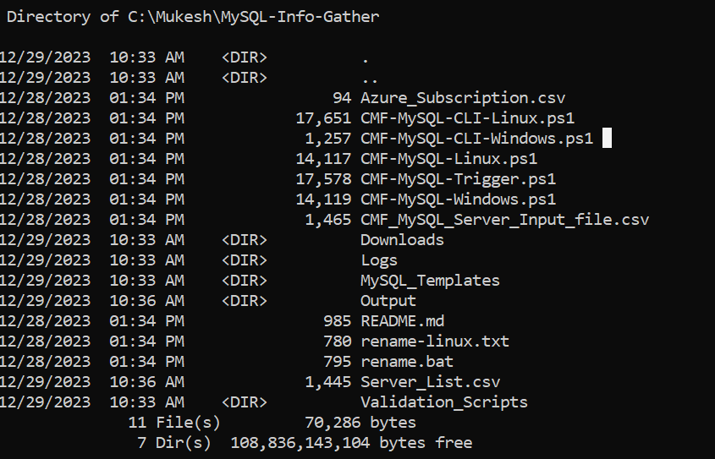\

**Note:** The file size may change based on the current policies and bug fixes

* Enter the following command at the windows command prompt to trigger the CMF-MySQL-CLI-Windows.ps1 script.

**Powershell.exe -ExecutionPolicy RemoteSigned -File .\** **CMF-MySQL-CLI-Windows.ps1**



### Create support folders( Logs, Output, Downloads etc)

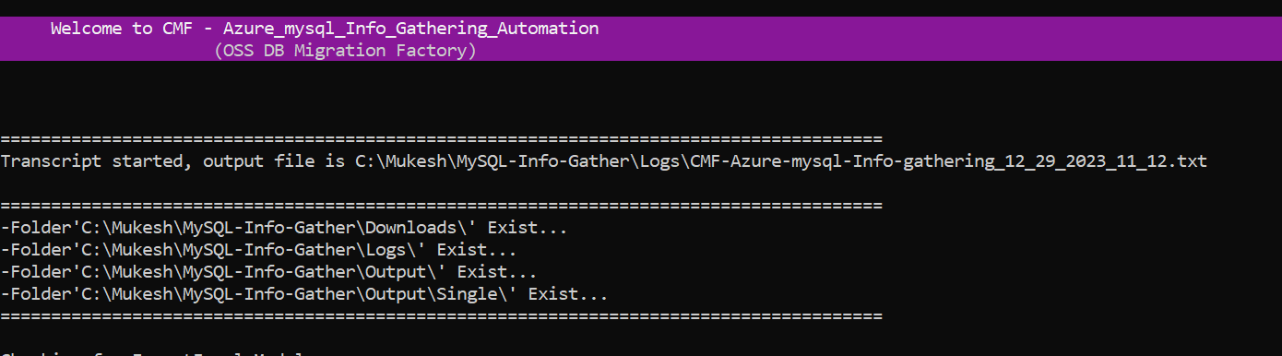

After triggering the automation all the support folders( Logs, Output, Downloads etc. ) will be created automatically by the automation script in the C:\MySQL folder

### Validate Azure CLI

* Automation script validates the Azure CLI. If not found, automation will initiate installation

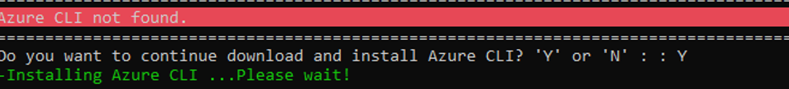

* Once Azure CLI Installation completes successfully and if you encounter above error message kindly close the Command Prompt and validate Azure CLI by re-running the automation script again.

* PowerShell version and Azure CLI are validated successfully.

### Azure Portal authentication

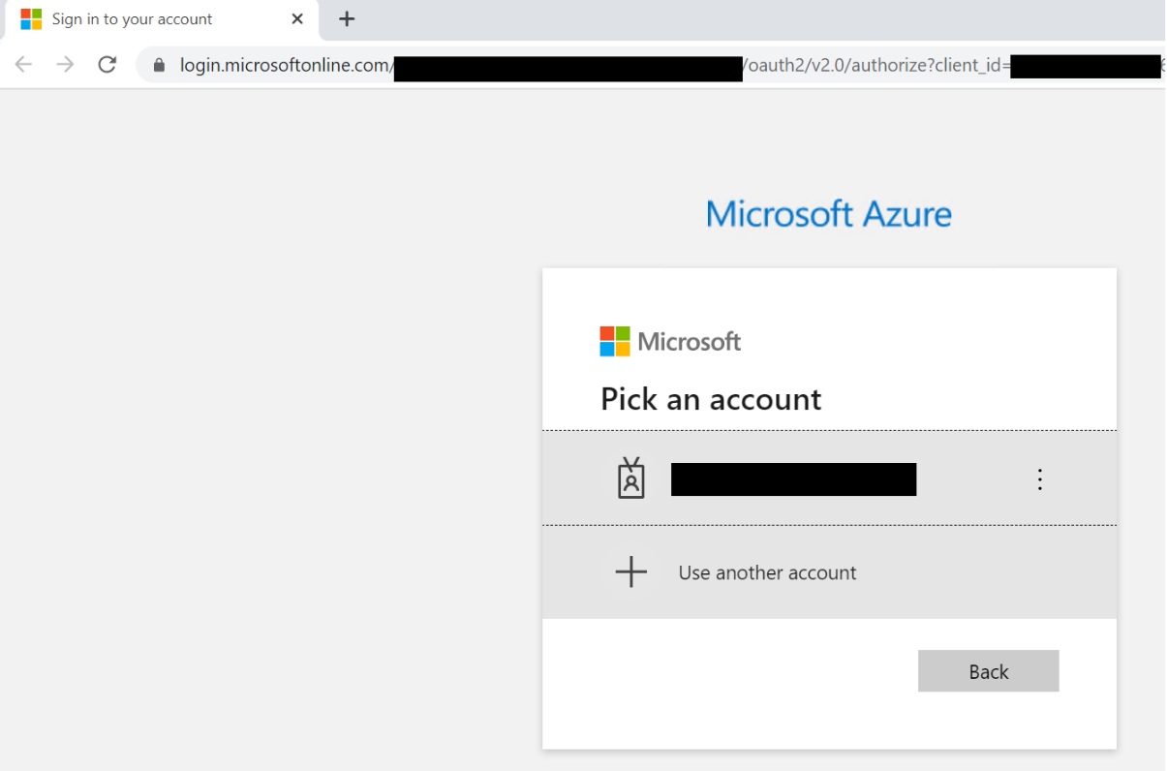

* Automation requires the Azure portal authentication

### Export Info-Gathering details and generating JSON files

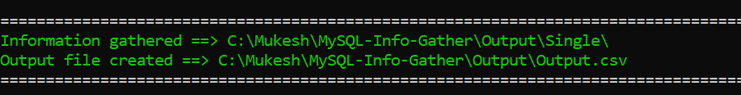

Once Azure portal authentication is successful, Automation gathers MySQL Single server details to update them in spread sheet. Also, Azure MySQL CLI’s commands output will be exported to JSON files.

* The JSON files can be found in the Folder Output 🡪 Single

## Server_List CSV File

**Note:**

* “Initially except the headers, the “Server_List” rows will be empty
* “**Server_List**” csv file will be automatically populated with the details of the MySQL Single server/instance i.e. Host_Name, Resource_Group, Port, VCore, User_ID, Auth_Type, Tenant_ID, Subscription_ID , SSL_Mode **once the Script execution is complete**
* You can use these server details and copy it to the CMF-MySQL_Server_Input_file.csv for Windows/Linux MySQL Server Info-gathering

### Azure MySQL Single Server JSON output

The Following JSON output files will be generated for each Azure MySQL Single Server from the given Azure subscription.

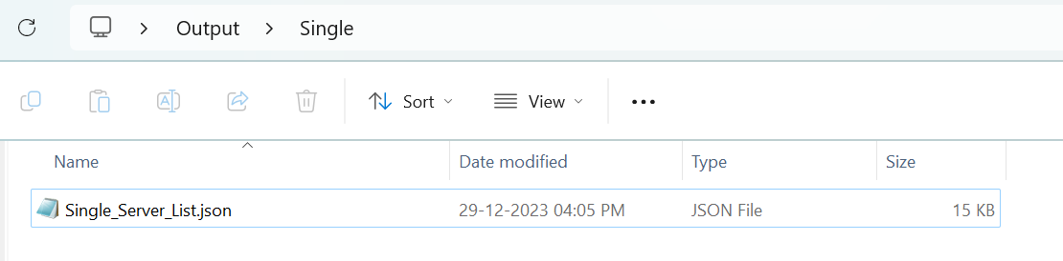

## Azure MySQL Single Server Output excel file

Output.xlsx file will be generated for all the MySQL Single Server/Instance(s) from the given Azure subscription. Azure CLI’s output are as follow.

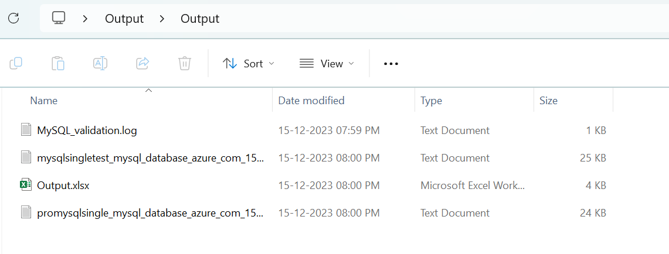

## Azure MySQL Single server Output excel file

Output.xlsx file will be generated for all the MySQL single Server/Instance(s) from the given azure subscription. Azure CLI’s are as follow.

* Server List
* DB List
* Server Configuration List
* AD-Admin List
* Firewall-rule List
* Replication List

**Note:** output file will be generated in excel format as above (.\Output\Output.xlsx)

Note: work sheets will be created with details in output.xlsx file as above.

## Automation Script Transcript Log

**Note:** For the Automation, transcript will be generated in text format as above

(.\Logs\CMF-Azure-MySQL-Info-gathering.txt)